LESTUPGRADE DATA STRUCTURES AND ALGORITHM

DAY 3 ASSIGNMENT

Q1) Write a function “insert_any()” for inserting a node at any given position of the linked list. Assume position starts at 0.

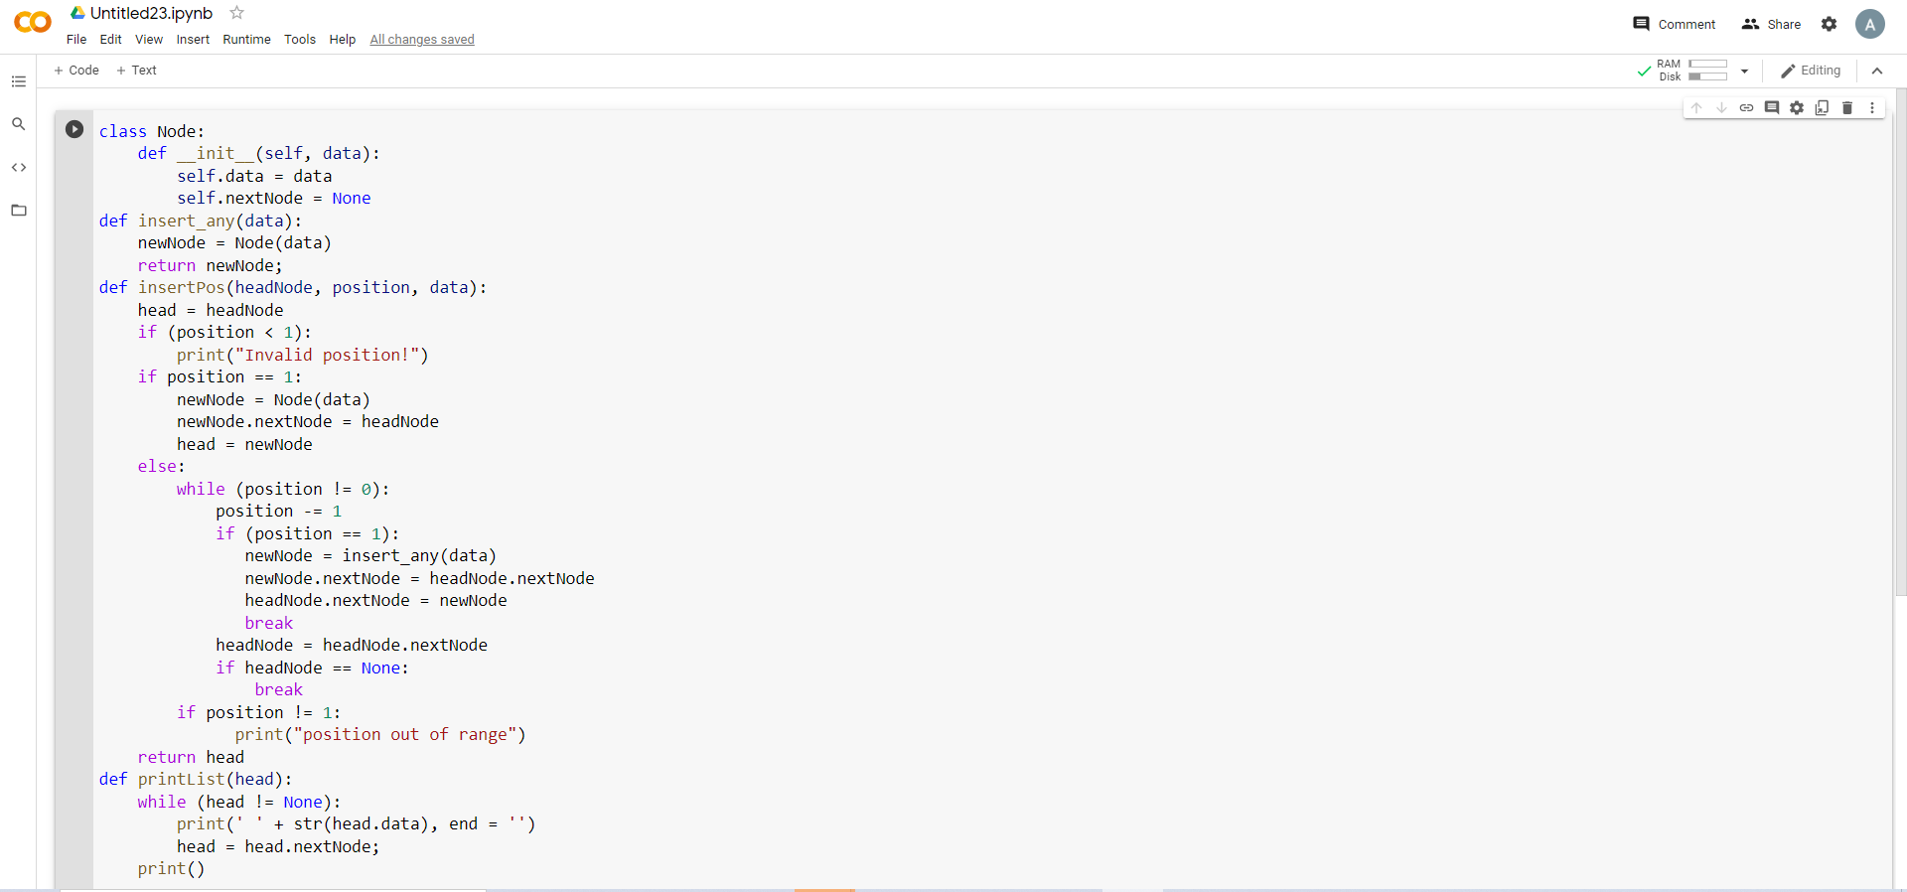

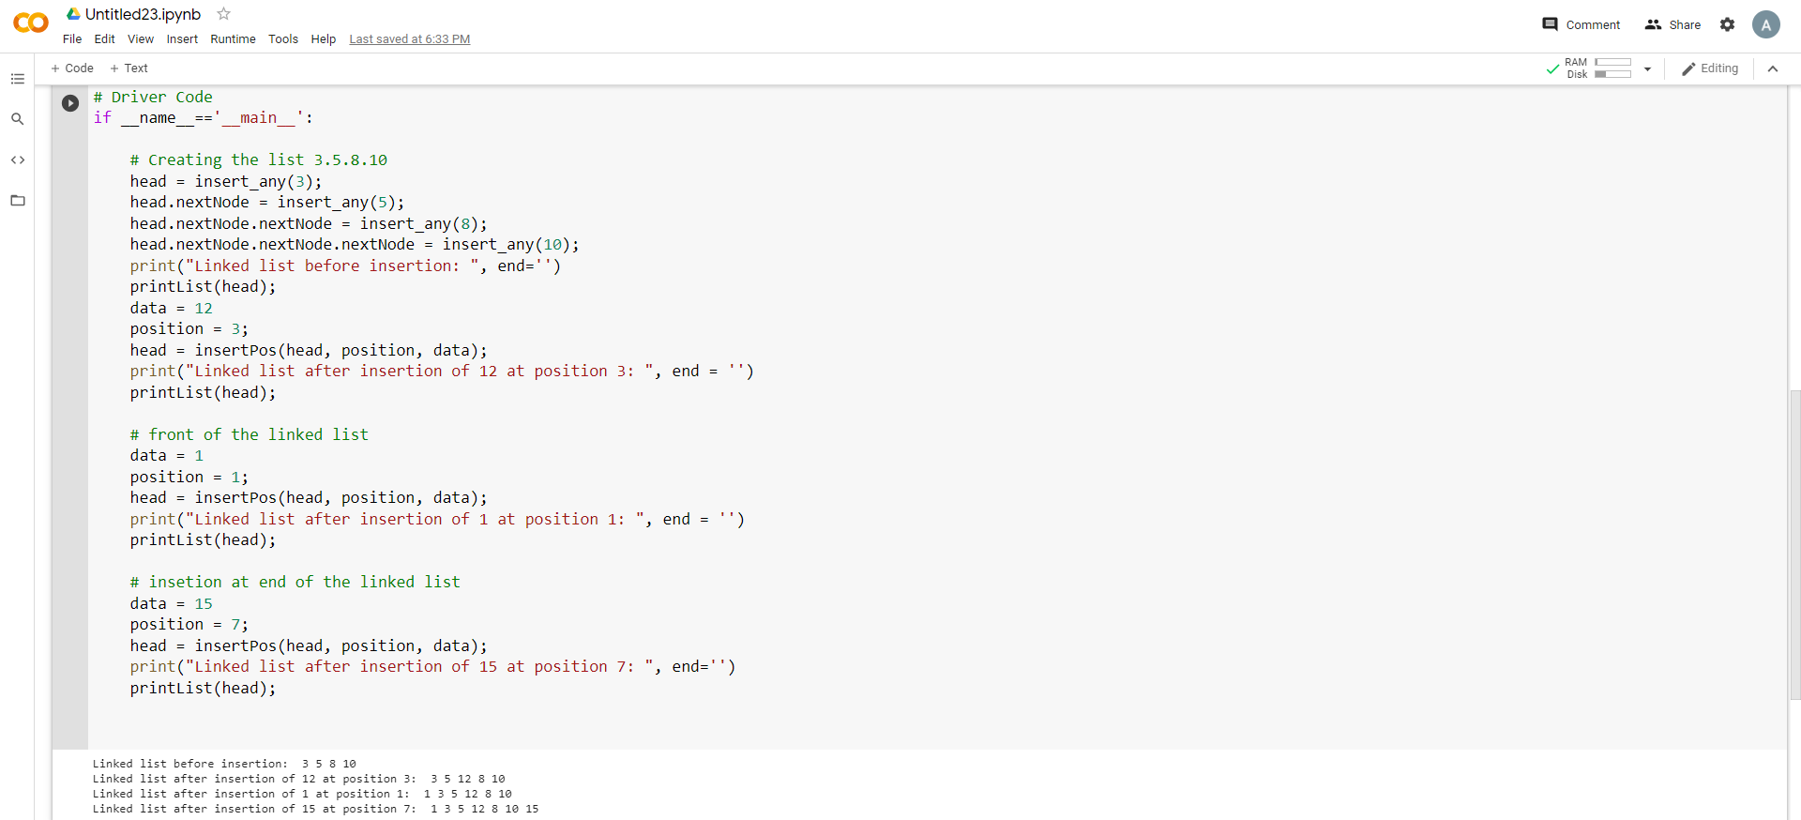

Q2) Write a function “delete_beg()” for deleting a node from the beginning of the linked list.

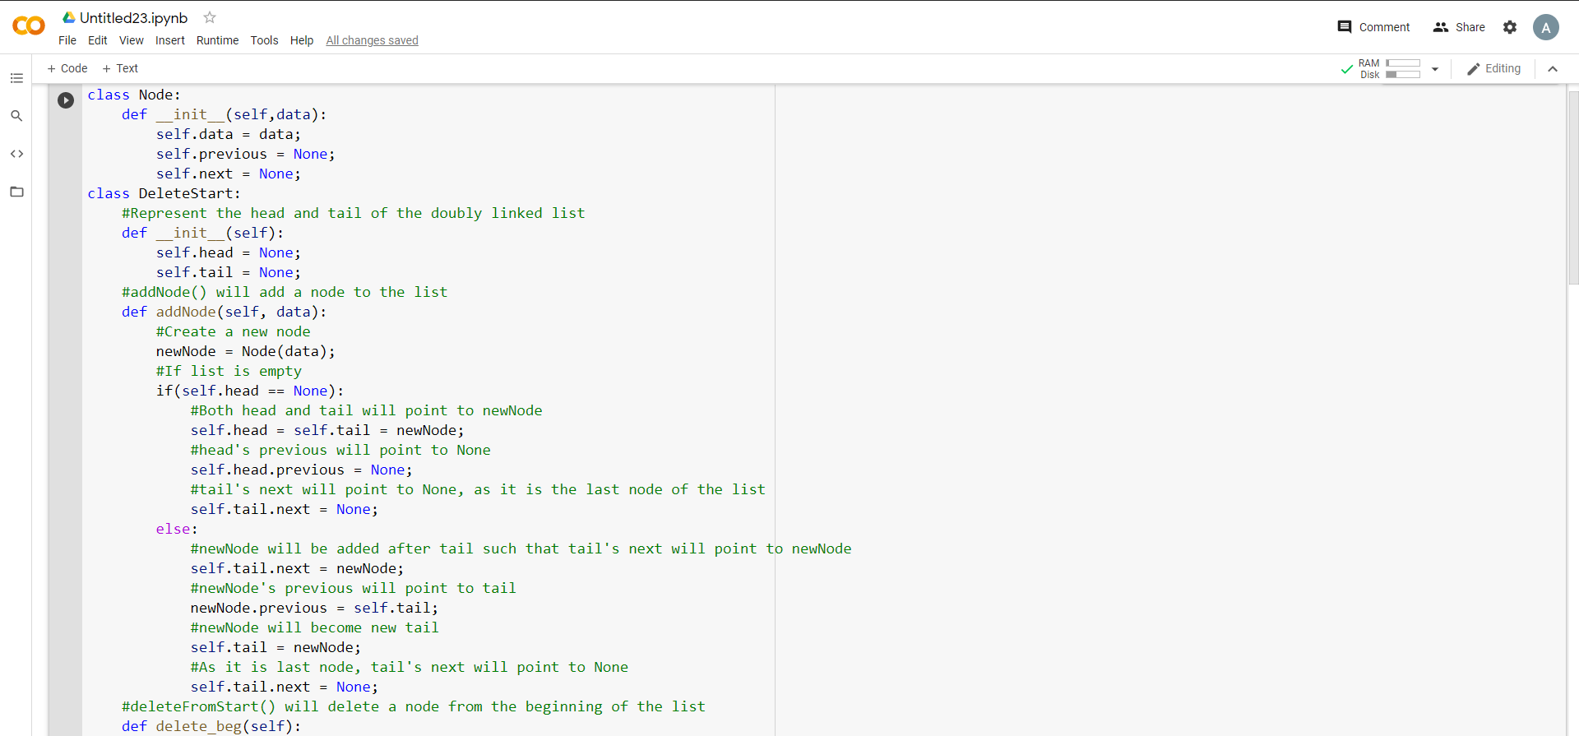

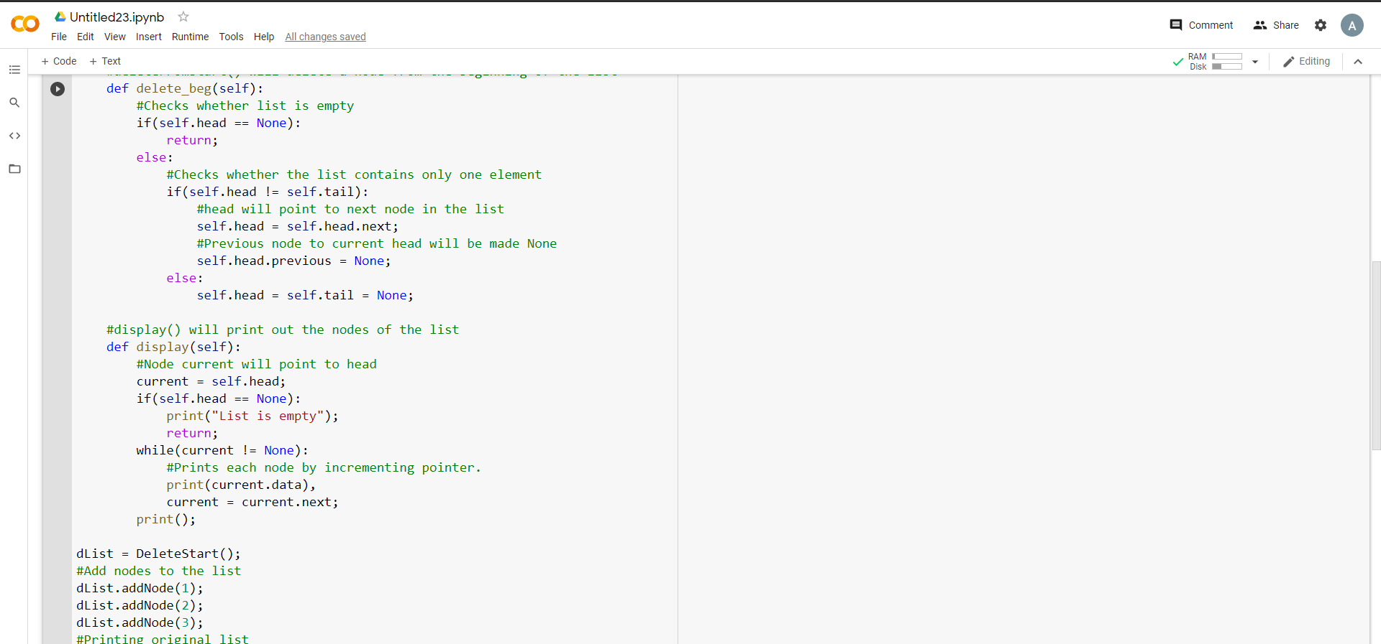

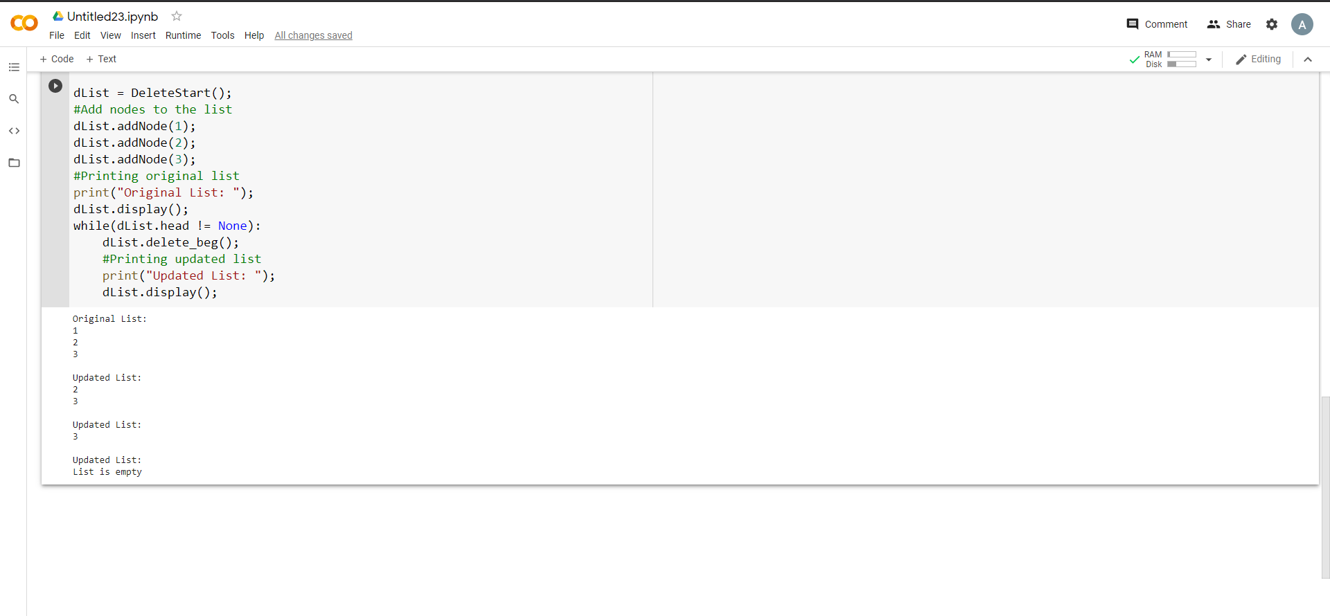

Q3) Write a function “delete_end()” for deleting a node from the end of the linked list.

